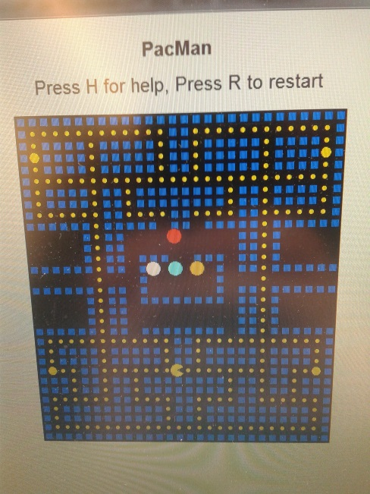Story Board for 3D Pac Man

My game consists of 2 modes: the 2D mode and the 3D mode.

The 2D mode is the classical Pac Man, with similar controls, AIs and rules.

If there is more time, I shall design higher levels for this.

For rules and Ai, see http://gameinternals.com/post/2072558330/understanding-pac-man-ghost-behavior

Then there is the 3D mode:

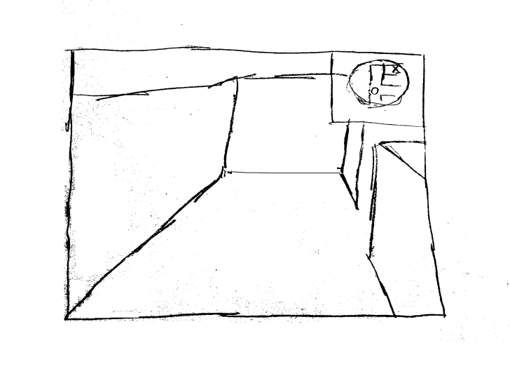

This is the basic 3D user interface.

The top right corner is a map, which is part of the 2D game board.

The middle of the screen is the user’s view.

Additional Features including lives, points will be added in the interface.

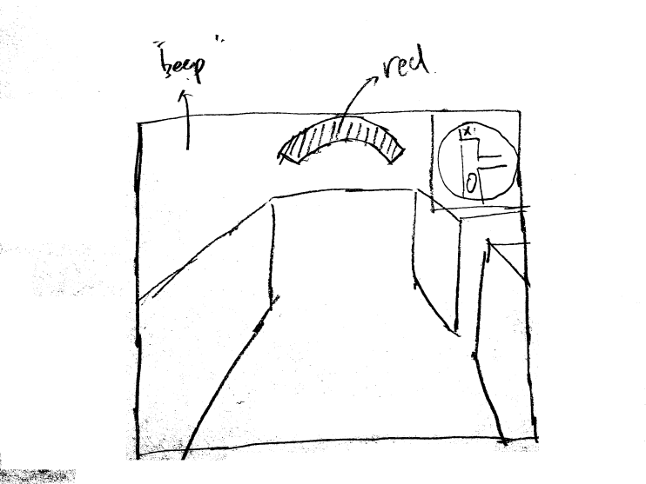The details will be described in the following pictures.

When a ghost is nearby, a red bar will be displayed on the screen, at the direction where the ghost is located. There will also be beeps as the ghost approaches the Pac man.

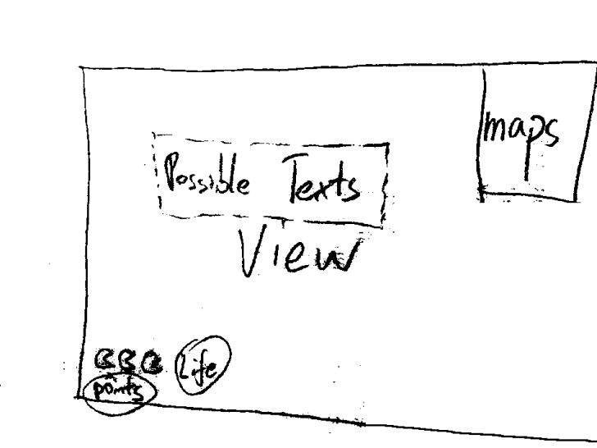These are the details of the user interface.

Possible Texts: possible state hints (energized)

View: 3D view

Maps: 2D view

Life: Remaining lives

Points: Current Points